NAME: MUHAMMAD AHSAN NAEEM
ROLL:F2024332104
SEC D1
LAB TASKS
Q1:
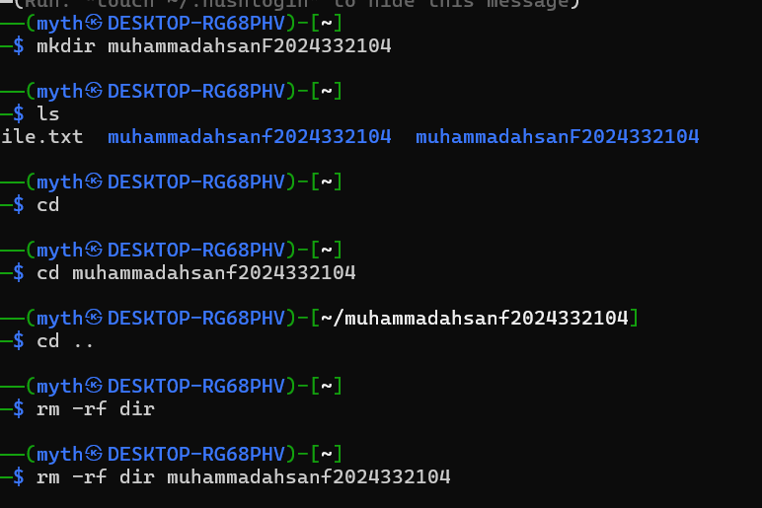
Q2:
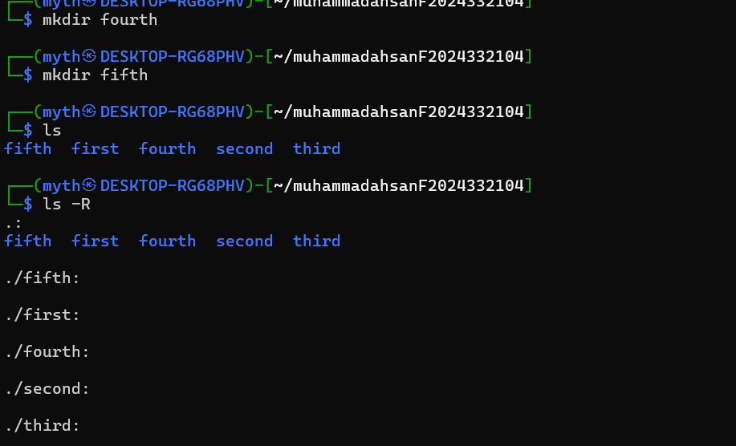
Q3:
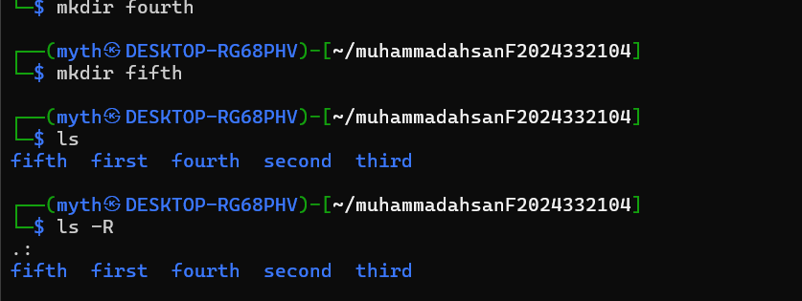
Q4AND 5:
